**Student details**

NAME: Mithun Ragavendiran

Reg no: 5104211004059

Class: CSE-3rd year

Clg name: Arunai engineering college

Sub: angularJS

**PROGRAM:**

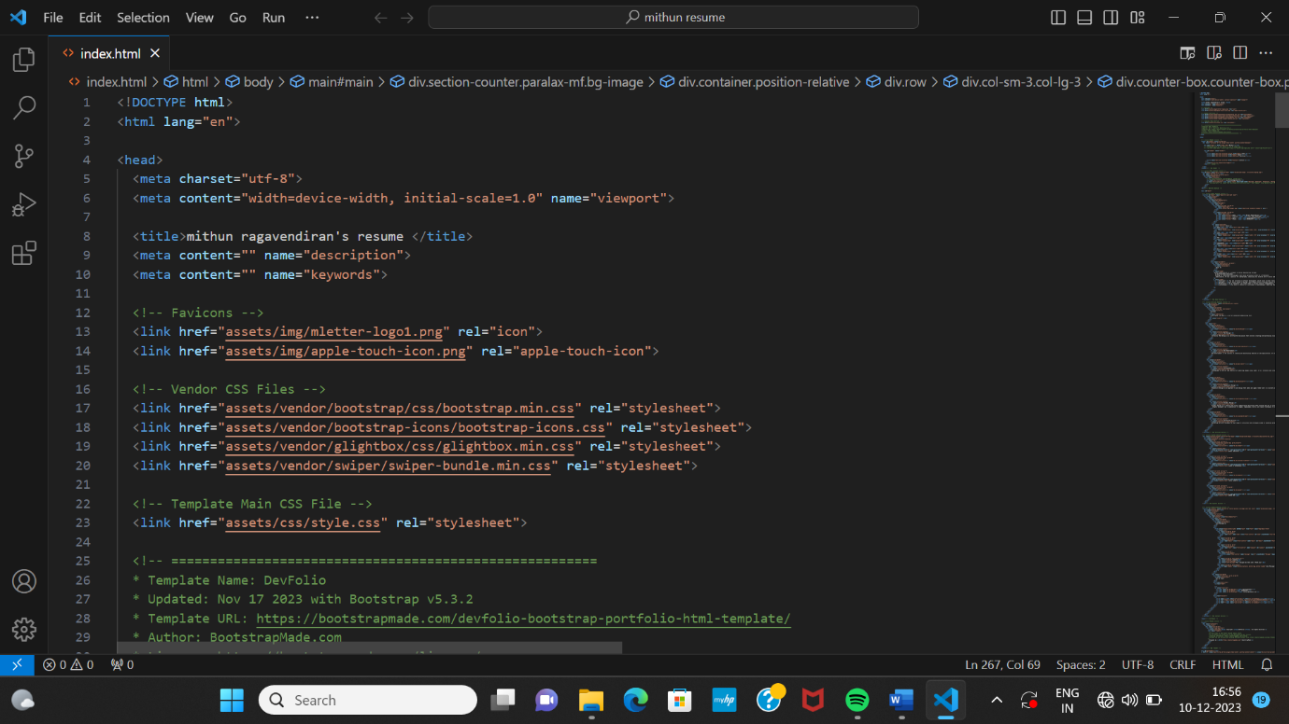

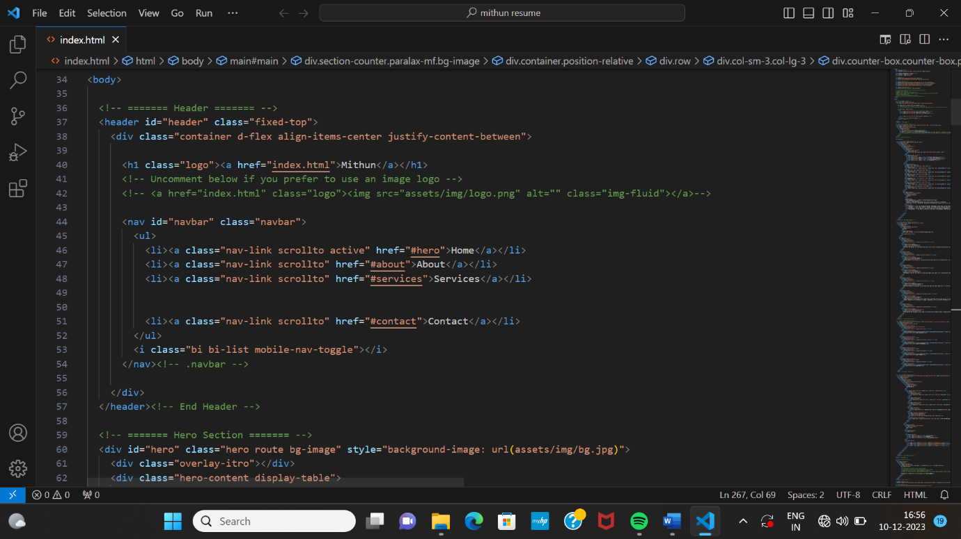

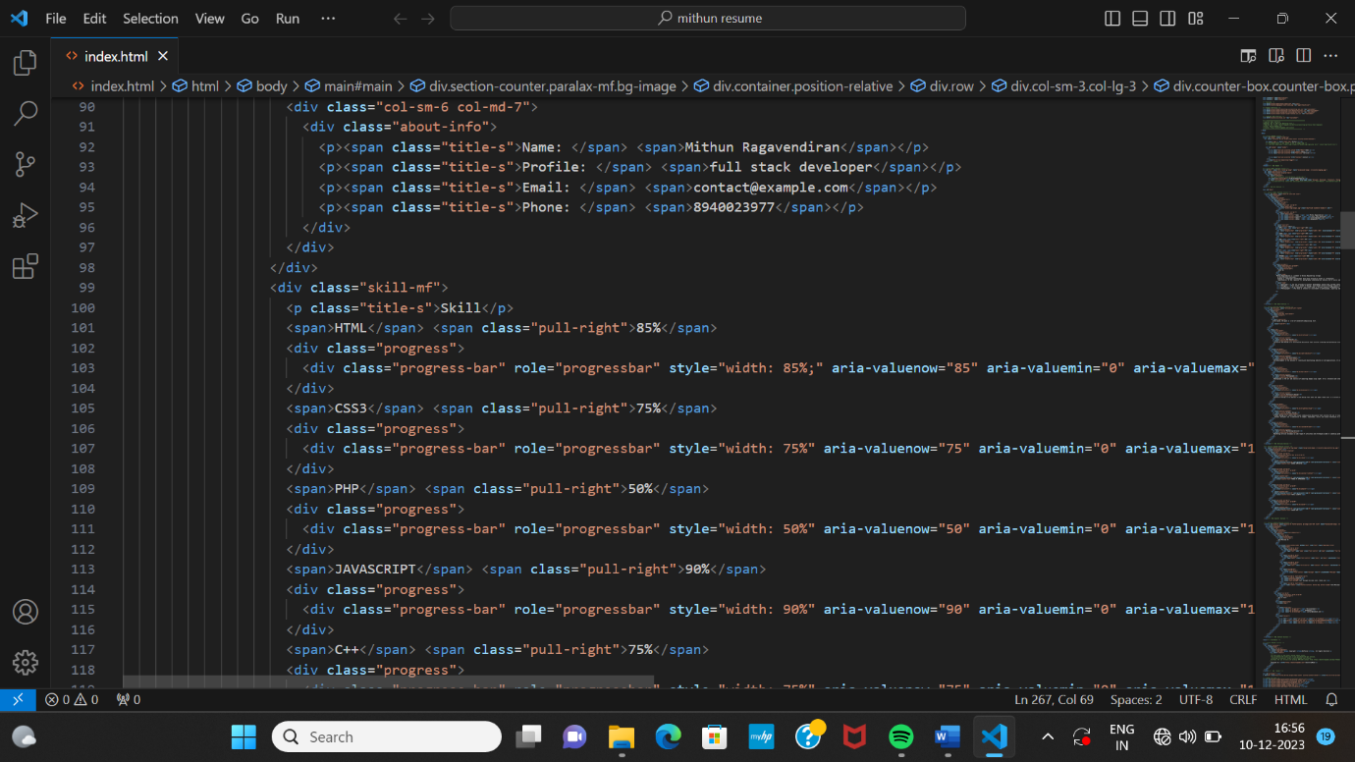

**OUTPUT:**

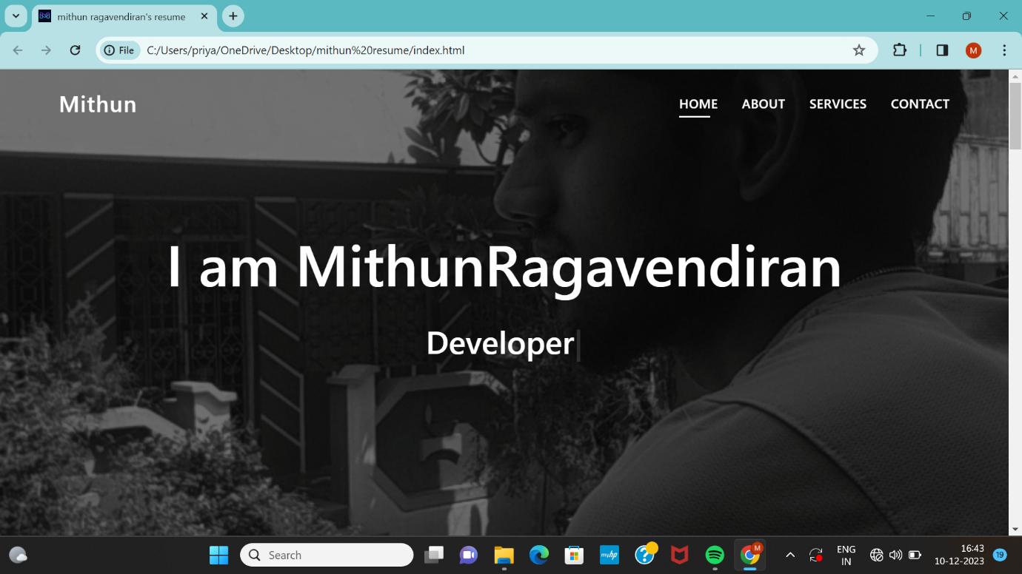



**GitHub Repository Link:**

<https://github.com/MithunRagavendiran/portfolio_site>

**Deployment website link:** <https://mithunragavendiran.github.io/portfolio_site/mithun%20resume/index.html>